INTERNSHIP REPORT

MARKET ANALYSIS

SUBMITTED BY

BALA PRANAV

3RD YEAR

ARTIFICIAL INTELLIGENCE AND DATA SCIENCE

# About the dataset:

This data typically includes the tickers which is Netflix, Google, Microsoft and Apple. It also contains the high, low, Adjacent close, Volume of the tickers.

* **Date** - specifies trading date
* **Open** - opening price
* **High** - maximum price during the day
* **Low** - minimum price during the day
* **Close** - close price adjusted for splits
* **Adj Close** - adjusted close price adjusted for both dividends and splits.
* **Volume** - the number of shares that changed hands during a given day

# Steps to follow for Analysing:

**1. Define the Scope and Objective:**

○ Identify the market or industry you want to analyze.

○ Define the specific objectives of your analysis (e.g., identifying market

trends, understanding competitive landscape, etc.).

**2. Data Collection:**

○ Gather relevant data from various sources (e.g., financial reports,

market research reports, government databases, etc.).

○ Common data points include market size, market share, growth rates,

consumer demographics, competitive analysis, etc.

**3. Data Preparation:**

○ Clean the data to remove any inconsistencies or errors.

○ Combine data from different sources into a single dataset.

○ Use tools like Excel or SQL for data cleaning and preparation.

**4. Load Data into Tableau:**

○ Open Tableau and connect to your data source.

○ Load your prepared dataset into Tableau.

**5. Create Initial Visualizations:**

○ Start by creating basic visualizations to understand the data.

○ Use different chart types like bar charts, line charts, pie charts, and

scatter plots to visualize various aspects of the data.

# STEPS:

1. Load the dataset:

df=pd.read_csv('stocks.csv')

1. Identify whether null values is present:

* If present remove or replace it.
* Else proceed to next step.

df.isnull().sum()

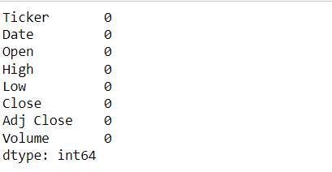

Here there is null values so proceed with Tableau.

1. Connect to Data:

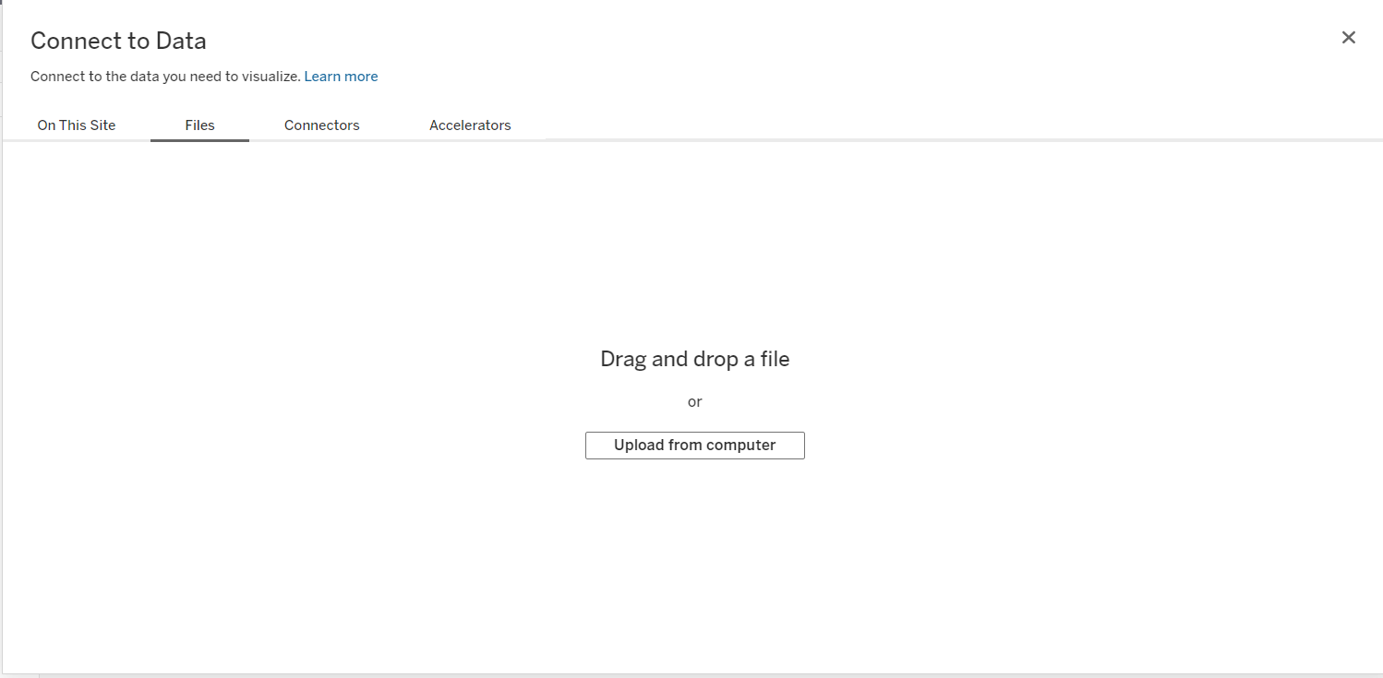

Drag and drop here to connect the dataset to workbook.

1. Bar chart for volume and tickers

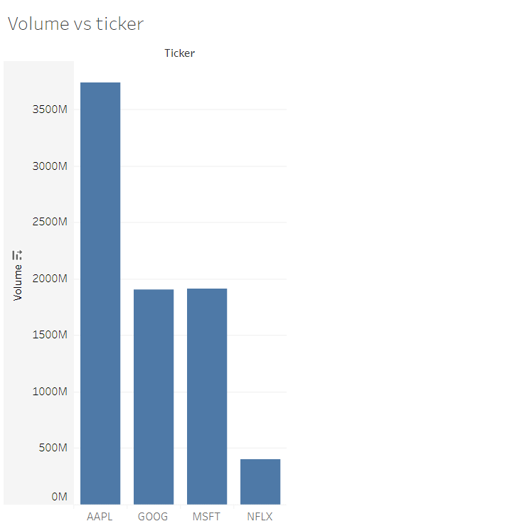

1. Dual axis line chart for high and low price sales.

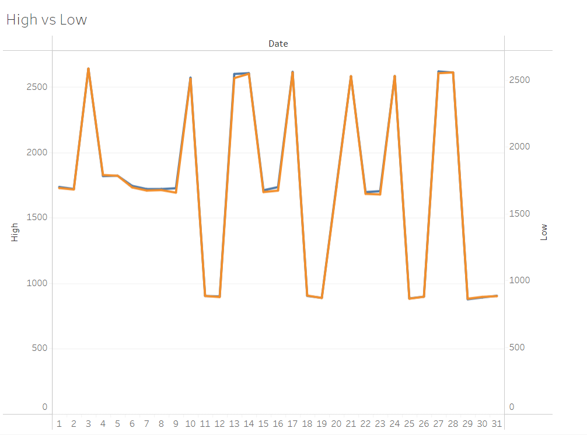

1. Pie chart for visualizing volume for respective fields.

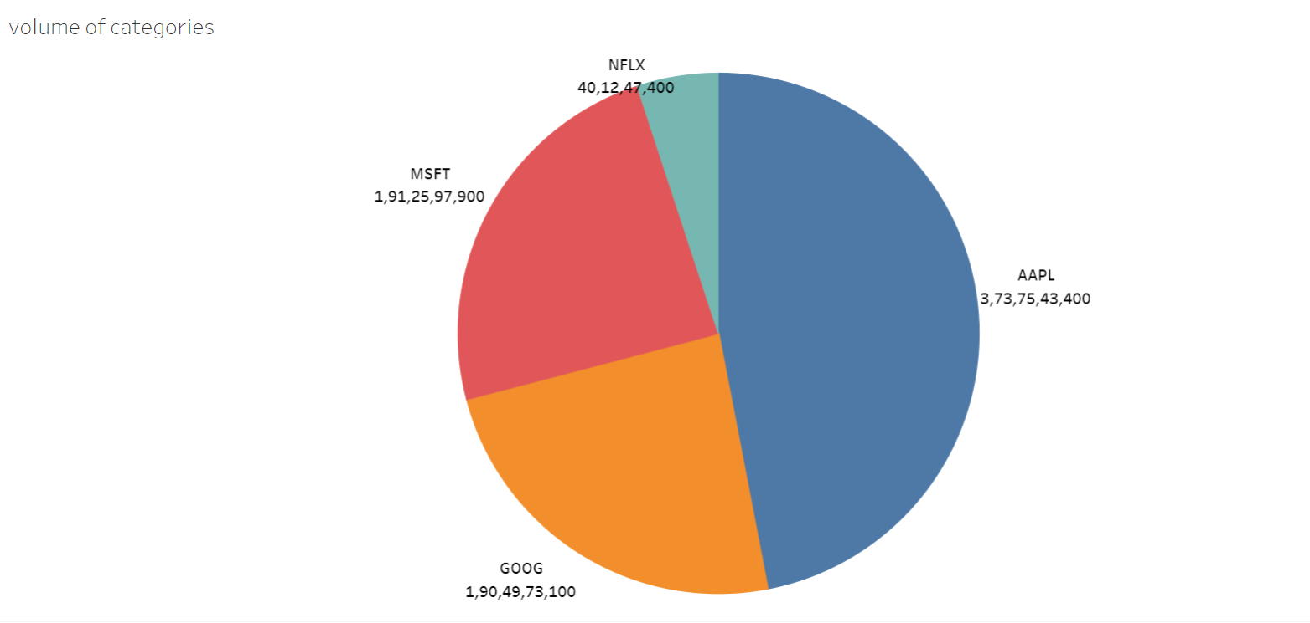

1. Visualizing a line chart for stock count(daily basis)

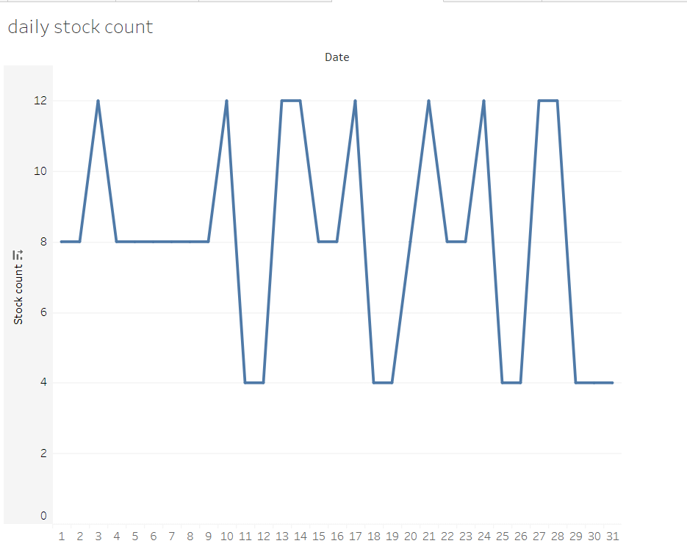

1. A line chart for adjacent close prices(daily basis).

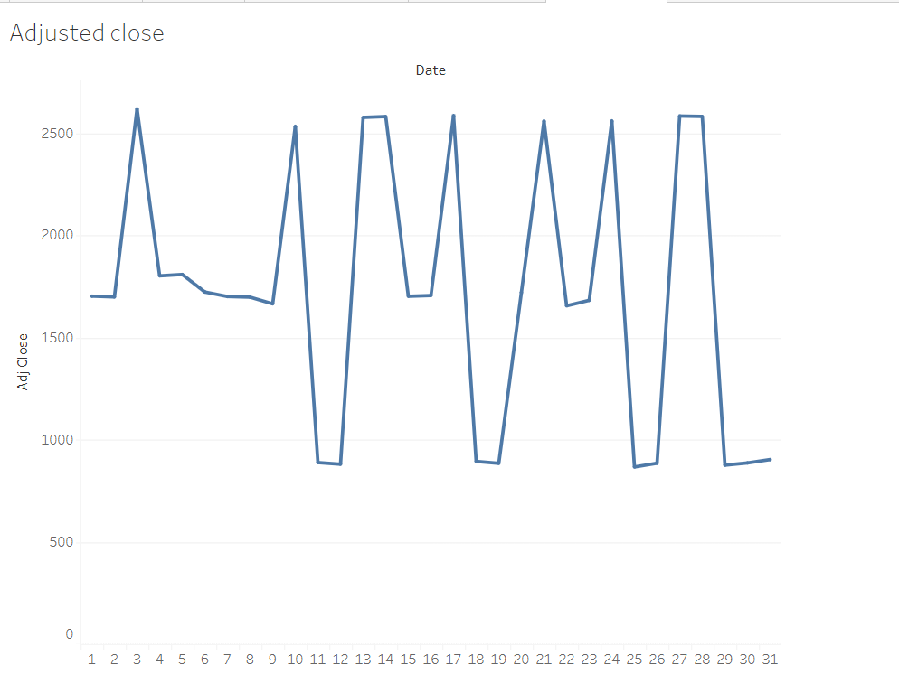

# CONCLUSION:

Tableau is a good tool for visualizing various trends and insights in the field of market, stock. All you need to know is the basic elements and type of charts used for analysing. I think this project gives an idea about the analysis and visualization.